Name: _______________________________________________________ Class: 3____ Shift: ____
2025 TERM ONE MZIMBA NORTH DISTRICT EXAMINATIONS

GEOGRAPHY
Subject Number: M073/I
Time Allowed: 2 hours 30 min
Date: Monday, 15 Dec, 2025 7:30-10:00am
(100 marks)
MAP READING AND PHYSICAL GEOGRAPHY

Instructions
Question number | Tick if answered | Do not write in these columns
- - 3
4
5
- This paper contains 9 pages. Please check.
- The paper has five questions.
- There are two sections, A and B.
- Section A comprises of three questions and candidates must answer all the three questions.
- Section B comprises two questions and candidates must answer one question only.
- Write your Name on top of each page of the question paper.
- In the table provided on this page tick against the number of question you have answered.

Turn Over
©2025/26 MZIMBA NORTH

SECTION A (85 marks)
Answer all the questions in the section in the spaces provided
1. Study the 1: 50000 map extract of Madisi and answer the questions that follows

a) (i) Give the six figure grid reference of borehole BH K11
___________________________________________________________________ (2 marks)
(ii) Mention any one way in which relief have been represented on the map
_____________________________________________________________________________

(1 mark)
b) (i) Measure the length of the M1road from the junction with secondary road (6417) to the junction with tertiary road (6813).
_____________________________________________________________________ (3 marks)
(ii) Mention any one land uses done to the South West of the map
__________________________________________________________________(1 mark)
c) Measure the bearing of the Mtiti school from Madisi Luthern Church
_______________________________________________________________ (3 marks)
d) (i) Calculate the area of land that is bordered by Namsanje and Kawelewela rivers on the map.

(5 marks)
(ii) Identify main settlement pattern displayed on the map
_______________________________________________________________________________

(1 mark)
(iii) Identify the landform shown in grid square 7018 on the map
_______________________________________________________________________________

(1 mark)

e) Enlarge the area to the west of easting 63 and south of northing 12 to twice its original size.
(4 marks)
On the enlarged map, show the following
(i) The new scale (2 marks)
(ii) Nkhonde Estate (2 marks)
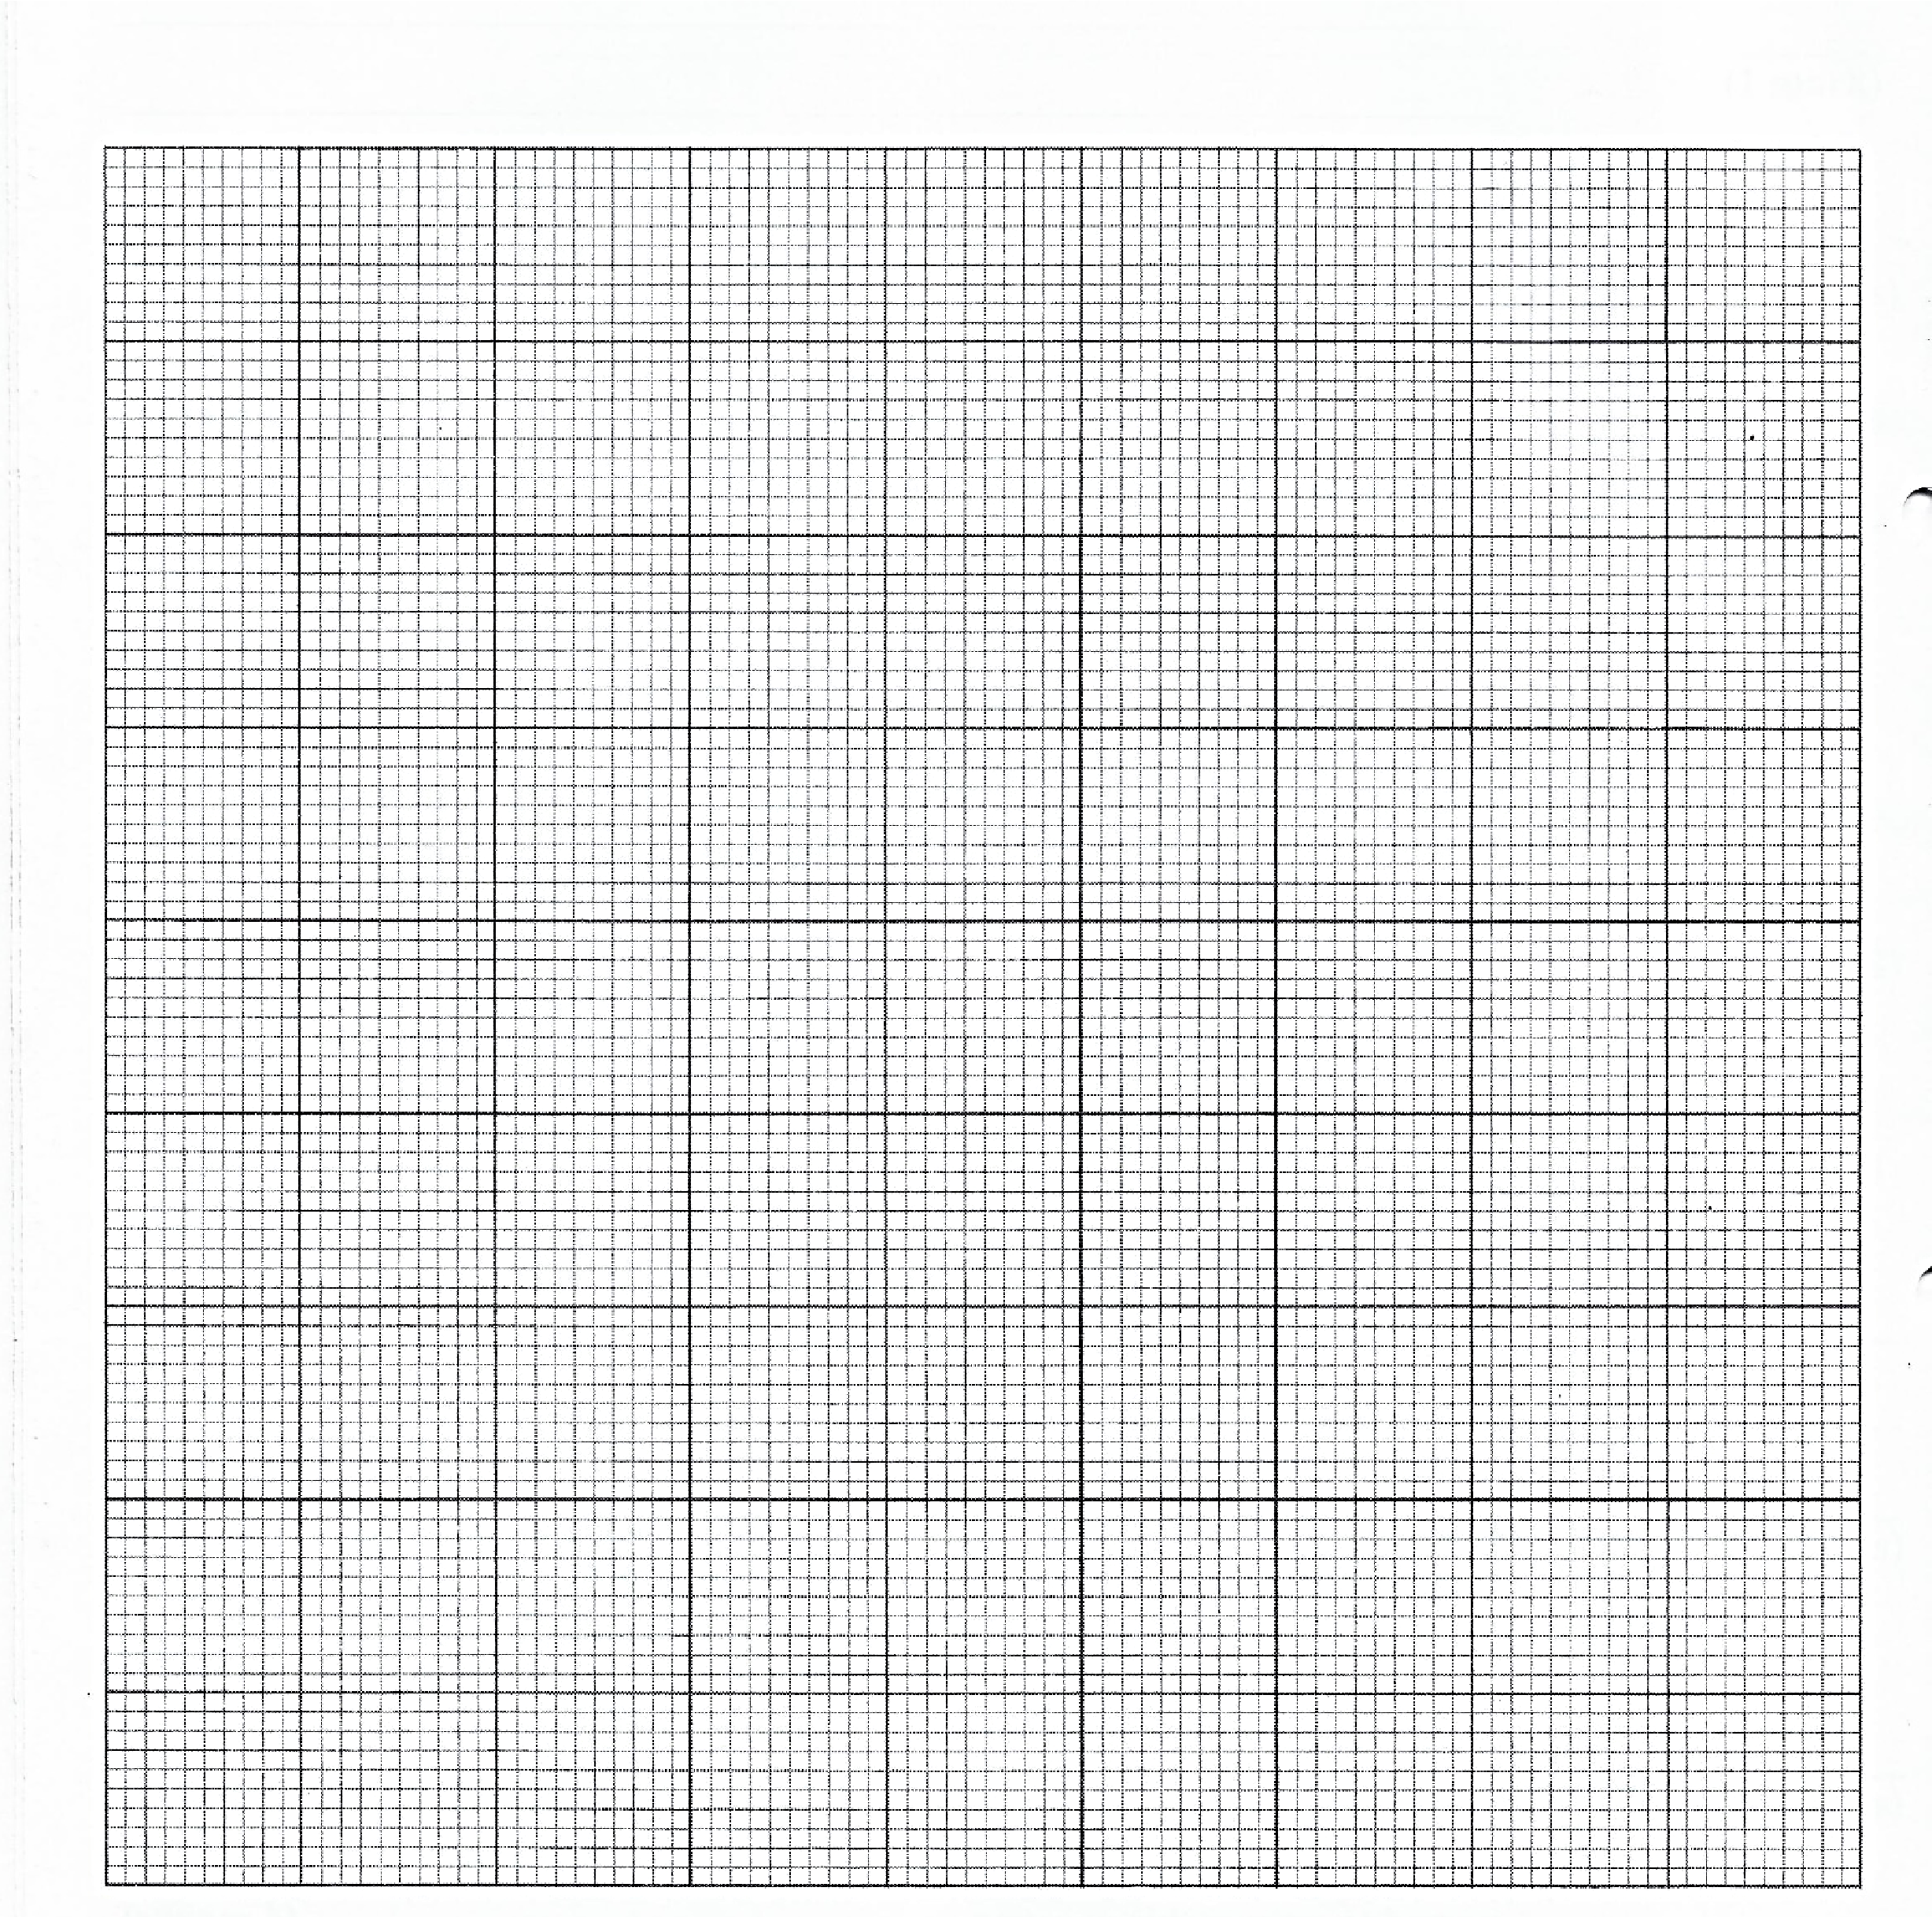
(iii) Borehole (BH GK 145) (2 marks)

2. a. (i) State any two types of crustal plates
________________________________________________________________________________
________________________________________________________________________________

(2 marks)
(ii) Describe the process that led to the formation of Mariana Trench
________________________________________________________________________________________________________________________________________________________________________________________________________________________________________(2 marks)
(iii) Give any two economic benefits of the valley in which Lake Malawi is found
_____________________________________________________________________________________________________________________________________________________ (2 marks)
(iv) State any one way in which levees are important
_________________________________________________________________________________________________________________________________________________________(1 mark)
b) (i) Explain how volcanic igneous rocks are formed
__________________________________________________________________________________________________________________________________________________________(2 marks)
(ii) From which rock do the following metamorphic rocks originate?
Metamorphic Rocks | Source Rock
Gneiss
Graphite

(2 marks)
d) Describe each of the following terms in relation to plate tectonics
A) Zone of subduction
__________________________________________________________________________________________________________________________________________________________________

(2 marks)
B) Sea Floor Spreading
________________________________________________________________________________________________________________________________________________________________ (2 marks)
e) (i) Explain any one reason why most fold mountains are located on the western continental margin.
__________________________________________________________________________________________________________________________________________________________________

(2 marks)
(iii) Describe the following terms in relation to volcanism
- Geysers
__________________________________________________________________________________________________________________________________________________________
(2 marks)
- Fumeroles
_________________________________________________________________________________________________________________________________________________ (2 marks)
f. Why volcano prone areas are densely populated despite the dangers they pose to human beings? Give any two points.
______________________________________________________________________________________________________________________________________________________________________________________________________________________________________________________________________________________________________________________ (4 marks)
3. a.(i) Name the two types of sedimentary rocks based on mode of formation.
________________________________________________________________________________________________________________________________________________________ (2 marks)
(ii) With the aid of a flow diagram, show the formation of igneous rocks.

(4 marks)
b. Explain the process through which a normal fault is formed.
________________________________________________________________________________________________________________________________________________________________________________________________________________________________________________ (3 marks)

c. Describe any two characteristics of young fold mountains?
________________________________________________________________________________________________________________________________________________________________________________________________________________________________________________________________________________________________________________________________________________________
(4 marks)
d. Describe any two importance of ox-bow lakes?
____________________________________________________________________________________________________________________________________________________________________________
____________________________________________________________________________________________________________________________________________________________________________
(4 marks)

Figure 1 below is a type of a delta. Use it to answer questions e (i) and e (ii) below.
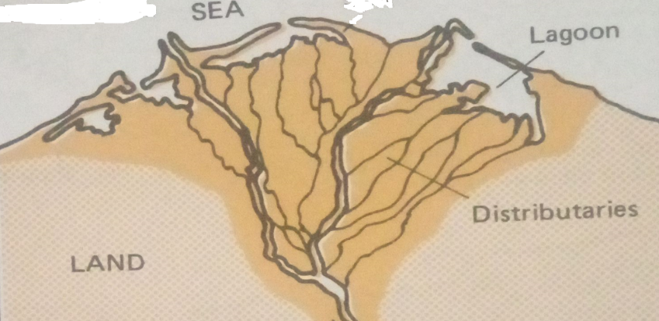
Figure 1
e (i) Identify the type of the delta in Figure 1 above.
__________________________________________________________________________ (1 mark)
(ii) Describe the process through which delta type in C (i) above is formed.
_______________________________________________________________________________________________________________________________________________________________________________________________________________________________________________________________
(3 marks)
f. Explain the influence of faulting on the following problems
1. Earthquakes
__________________________________________________________________________________________________________________________________________________________________________
- marks)
2. Drought
________________________________________________________________________________________________________________________________________________________________________
(2 marks)

SECTION B
(25 MARKS)
Answer only ONE question in this section
4. a) (i) Define the term continental drift
__________________________________________________________________________________________________________________________________________________________ (1 mark)
(ii) How do the following act as evidence supporting continental drift theory
A) Fitting of Southern continents
_______________________________________________________________________________
______________________________________________________________________(2 marks)
B) Similarity in rock sequence of the continents
_______________________________________________________________________________
_____________________________________________________________________ (2 marks)
b) (i) Describe any two effects of problems caused by faulting.
________________________________________________________________________________________________________________________________________________________________________________________________________________________________________________________________________________________________________________________________ (4 marks)
- Describe any two characteristics of Block Mountains.
__________________________________________________________________________________
__________________________________________________________________________________
__________________________________________________________________________________ __________________________________________________________________________________
- marks)
- With the aid of a diagram, describe the formation of rift valleys using tension forces.

(4 marks)
_________________________________________________________________________________________________________________________________________________________________________________________________________________________________________________________________________________________________________________________________________________________________________________________________________________________________________
(4 marks)
- (i) Define the term Vulcanicity
___________________________________________________________________________________
____________________________________________________________________________________ (1 mark)
(ii) Explain any two characteristics of volcanic mountains
____________________________________________________________________________________________________________________________________________________________________________________________________________________________________________________________________________________________________________________________________________________ (4 marks)
5. a) (i) Define the term ‘Data’
__________________________________________________________________________________________________________________________________________________________________ (1 mark)
ii. State any two forms of data
____________________________________________________________________________________________________________________________________________________________________ (2 marks)
iii. Describe the following ways of collecting data
- Observation
_______________________________________________________________________________________________________________________________________________________ (2 marks)
- Questionnaire
_______________________________________________________________________________________________________________________________________________________ (2 marks)
iv. Calculate the interquartile range using the data set below
5,6,6,7,8,8,9,11,12,13,13,15,17,18,19,19
(2 marks)
v. Present the following information in a pie chart, use radius of 2 cm and show your working.
Malawi’s exports in 2017 | Billion US $
Tobacco | 10
Maize | 7
Sugar | 4
Tea | 6
(7 marks)

b. With aid of well labelled diagrams, describe the process through which residual mountains are formed

________________________________________________________________________________________________________________________________________________________________________________________________________________________________________________________________________________________________________________________________
(5 marks)
c. (i) Give any two ways in which coastal landforms are economically important.
________________________________________________________________________________________________________________________________________________________________ (2marks)
(ii) Differentiate a delta from floodplain.
________________________________________________________________________________________________________________________________________________________________ (2marks)

END OF QUESTION PAPER

